OIAL Model Change Algorithms
Contributors: Shane Bray, David DeWinter, Brice Lambson
Abstract: This paper proposes a solution to the problem of keeping a live OIAL model in sync with an ORM Model. In this paper, we attempt to outline what changes to the OIAL model will appropriately correspond to the addition, change, and deletion of all ORM model elements that affect the absorption algorithm.
Contents
- Simple Mandatory Role Constraints
  - Add
  - Remove
  - Change (Modality)
- Internal Uniqueness Constraints
  - Add
  - Remove
  - Change (Modality, Role Sequence, Is Preferred)
- External Uniqueness Constraints (Preferred Identifier)
  - Add
  - Remove
  - Change (Modality, Role Sequence, Is Preferred)
- Disjunctive Mandatory Constraints
- Object Types
  - Change (Is Independent)
- Fact Types

Simple Mandatory Role Constraints
- Adding a mandatory role constraint.
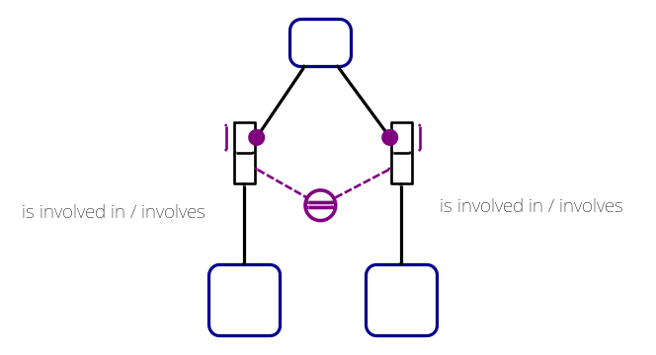
  - Case 1: Fact Type is many-to-many.

    - Do nothing. Mandatory role constraints on many-to-many fact types do not seem to affect anything.

  - Case 2: Fact Type is many-to-one or one-to-many.
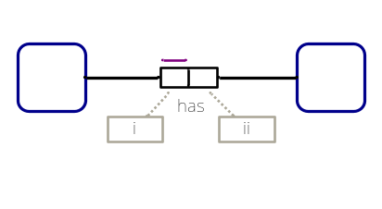
    - If the mandatory role constraint is on the side of the role with the single-role uniqueness constraint, then if an Information Type or a Concept Type Ref captures that exact relationship, add the OIAL equivalent of a mandatory role constraint on that relationship and set its value to MandatoryConstraintModality.Alethic.
    - If the mandatory role constraint is added to the opposite role of the role with the single-role uniqueness constraint, then no change results.
    - The previous cases also hold true when the one role already has a simple mandatory role constraint on it.
  - Case 3: Fact Type is one-to-one.
    - Subcase 1: After the addition, there is only one mandatory role constraint.
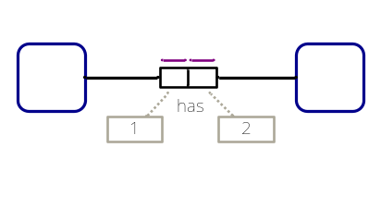
      - If a simple mandatory role constraint is added to the side marked with “1,” then there are two options:
        - If B does not play any functional roles, then A absorbs B with a fact absorption type of fact-only. Because the relationship started as fact-only and ended at fact-only, the only change is to make the Information Type generated for the non-mandatory role player mandatory with a value of MandatoryConstraintModality.Alethic.
        - If B does play functional roles, then B absorbs A with a fact absorption type of fully. Since the relationship changed from fact-only to fully, both role players will need Concept Types created for them (if they have not been created already), and the non-mandatory role player’s Concept Type will absorb the other Concept Type.
      - If a simple mandatory role constraint is added to the side marked with “2,” then there are two options, which are similar to the last two options, only reversed:
        - If A does not play any functional roles, then B absorbs A with a fact absorption type of fact-only. Because the relationship started as fact-only and ended at fact-only, the only change is to make the Information Type generated for the non-mandatory role player mandatory with a value of MandatoryConstraintModality.Alethic.
        - If A does play functional roles, then A absorbs B with a fact absorption type of fully. Since the relationship changed from fact-only to fully, both role players will need Concept Types created for them (if they have not been created already), and the non-mandatory role player’s Concept Type will absorb the other Concept Type.
    - Subcase 2: After the addition, there are two mandatory role constraints.
      - Regardless of where the role players are absorbed, two mandatory role constraints will always result in a full absorption. Before the addition of the constraint, there was a type of absorption type for the fact type absorption. If it used to be fact-only, then two options can occur:
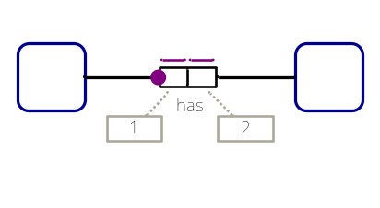
        - If the fact type represents a simple preferred identifier fact, then don’t do anything.
        - Otherwise, create a Concept Type for the role player that is not already a Concept Type (the non-mandatory role player before the addition of the constraint). Find the role player which plays more functional roles, and then make that one absorb the other Concept Type.
      - If the fact used to be fully absorbed, then set the Absorbed Concept Type’s mandatory value to be MandatoryConstraintModality.Alethic.
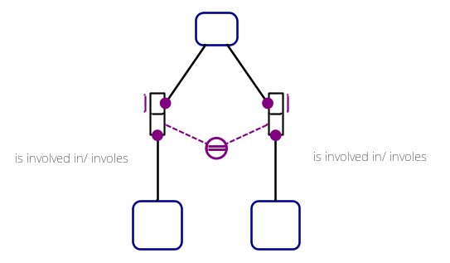
- Removing a mandatory role constraint.
  - Case 1: Fact Type is many-to-many.
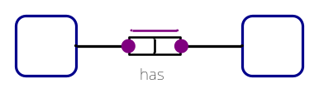
    - Do nothing. Mandatories on many-to-many fact types do not seem to affect anything.

  - Case 2: Fact Type is many-to-one or one-to-many.
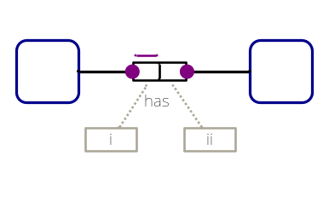
    - If the mandatory role constraint is on the side of the role with the single-role uniqueness constraint, then if an Information Type or a Concept Type Ref captures that exact relationship, add the OIAL equivalent of a mandatory role constraint on that relationship and set its value to MandatoryConstraintModality. NotMandatory.
    - If the mandatory role constraint is removed from the opposite role of the role with the single-role uniqueness constraint, then no change results.
    - The previous cases also hold true when the one role does not already have a simple mandatory role constraint on it.
  - Case 3: Fact Type is one-to-one.
    - Subcase 1: After removal, there is only one mandatory role constraint.
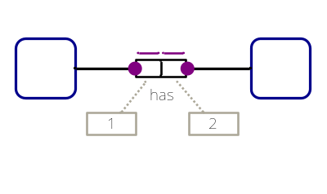
      - If a simple mandatory role constraint is removed from the side marked with “2,” then there are two options:
        - If B does not play any functional roles, then A absorbs B with a fact absorption type of fact-only. Since the relationship changed from fully to fact-only, the concept type for B will need to be removed. An Information Type for B must be created.
        - If B does play functional roles, B absorbs A with a fact absorption type of fully. Because the relationship started as fully and ended as fully, Concept Types already exist for both A and B, but depending on who plays more functional roles, absorption may change.
      - If a simple mandatory role constraint is removed from the side marked with “1,” then there are two options:
        - If A does not play any functional roles, then B absorbs A with a fact absorption type of fact-only. Since the relationship changed from fully to fact-only, the concept type for A will need to be removed. An Information Type for A must be created.
        - If A does play functional roles, A absorbs B with a fact absorption type of fully. Because the relationship started as fully and ended as fully, Concept Types already exist for both A and B, but depending on who plays more functional roles, absorption may change.
    - Subcase 2: After removal, there are no mandatory role constraints.
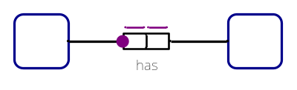
      - If B does not play any functional roles, A absorbs B with a fact absorption type of fact-only. Because the relationship started as fact-only and ended as fact-only, we only need to change the OIAL equivalent of the mandatory role constraint’s value to MandatoryConstraintModality.NotMandatory.
      - If B does play at least one functional role, one of two things may happen:
        - If A plays less functional roles than B, B absorbs A with a fact absorption type of fact-only. Since the relationship went from fully to fact-only, the Concept Type for A must be deleted. An Information Type for A must be created.
        - If A plays equal or more functional roles than B, A absorbs B with a fact absorption type of fact-only. Because the relationship started as fully and ended as fact-only, the concept type for A is no longer absorbed into the Concept Type for B. Concept Type A must include a Concept Type Reference for B.
- Changing a mandatory role constraint.
  - Case 1: Modality is changed from alethic to deontic.
    - Choose the appropriate remove case changing any value of MandatoryConstraintModality.Alethic to a value of MandatoryConstraintModality.Deontic.
  - Case 2: Modality is changed from deontic to alethic.
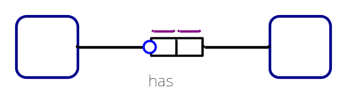
    - Choose the appropriate add case changing any value of MandatoryConstraintModality.Deontic to a value of MandatoryConstraintModality.Alethic.
Internal Uniqueness Constraints
- Adding an Internal Uniqueness Constraint
  - Case 1: Fact type is unary.
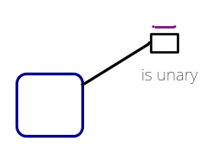
    - If the fact type is unary, then don’t make any changes in the OIAL.
  - Case 2: Fact type is binary and has no uniqueness constraints on it. A uniqueness constraint is added where the constraints spans only one role.
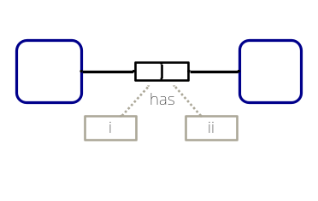
    - If a uniqueness constraint is added to the side with A on it, then there are two subcases:
      - If B is a Concept Type, then generate a Concept Type Ref from B to A. If A does not have a Concept Type created for it already, create it.
      - If B is not a Concept Type, then generate an Information Type for B to put in A. If A does not have a Concept Type created for it already, create it.
    - If a uniqueness constraint is added to the side with B on it, then there are also two subcases:
      - If A is a Concept Type, then generate a Concept Type Ref from A to B. If B does not have a Concept Type created for it already, create it.
      - If A is not a Concept Type, then generate an Information Type for A to put in B. If B does not have a Concept Type created for it already, create it.
    - For both of these cases, make sure to re-evaluate the absorption of one-to-one fact types that are linked to the role player whose role had a uniqueness constraint added on it. If the absorptions are changed, then switch the absorbers appropriately (i.e. everything that went into one Concept Type before needs to change its absorbing Concept Type).
  - Case 3: Fact type is binary and has no uniqueness constraints on it. A uniqueness constraint is added that spans both roles.
    - A concept type must be generated for the object type behind the fact type. For each of the implied facts, do Case Two, but remember there is no need to re-interpret one-to-one fact type absorption on the new concept type because it has just been created. Finally, create a Child Sequence Uniqueness Constraint that references A and B.
  - Case 4: Fact type is binary and has one single-role uniqueness constraint on it. A uniqueness constraint is added, thus making the fact type one-to-one.

    - Count the number of mandatory constraints on the binary fact type. Depending on the number of mandatory constraints on the fact type, calculate which object type wins the absorption and record the result in FactTypeAbsorptions, ObjectTypeAbsorptions, and TopLevelTypes if necessary. Make sure to remove the Information Type or the Concept Type Ref that existed previously.
    - Make sure to re-evaluate the absorption of one-to-one fact types that are linked to the role player whose role had a uniqueness constraint added on it. If the absorptions are changed, then switch the absorbers appropriately (i.e. everything that went into one Concept Type before needs to change its absorbing Concept Type).
- Removing an Internal Uniqueness Constraint
  - Case 1: Fact Type is Unary
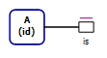
    - Do nothing. Internal Uniqueness Constraints on Unary Fact Types are implied and do not affect anything.
  - Case 2: After Removal, there are no Internal Uniqueness Constraints
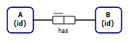
    - Remove the Information Type or Concept Type Reference for B based on Path Role. Also check the absorption of one-to-one fact types on A.
  - Case 3: Fact Type is one-to-one.
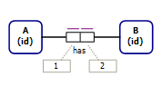
Note: Check absorption of one-to-one fact types on role player with the removed uniqueness constraint role.
    - Subcase 1: There are two Concept Types and B absorbs A with a fact absorption type of fact-only. (B and A have to play other functional roles.)
      - Remove the Concept Type Reference to A in B including any Single Column Uniqueness Constraints. Create a Concept Type Reference to B in A.
      - Remove the Single Column Uniqueness Constraint for the Concept Type Reference to B in A.
    - Subcase 2: There is one Concept Type and B absorbs A with a fact absorption type of fact-only. (Only A plays other functional roles.)
      - Create a Concept Type for B with a Concept Type Reference to A.
      - Remove the Single Column Uniqueness Constraint for the Information Type of B in A.
    - Subcase 3: There are two Concept Types and A absorbs B with a fact absorption type of fully. (Only B must play other functional roles.)
      - Remove the Absorbed Concept Type of A from B. If A plays other functional roles, keep the Concept Type for A and add a Concept Type Reference to A in B. Otherwise, delete the Concept Type and add an Information Type for A in B. If role for B is mandatory, set the relationship’s Mandatory value to MandatoryConstraintModality.Alethic.
      - Create a Concept Type for B, and add a Concept Type Reference to B in A with a Mandatory property set to MandatoryConstraintModality.Alethic.
  - Objectified Fact Types:
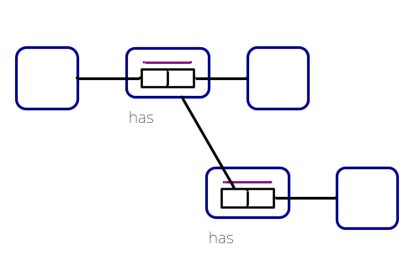
    - Delete Concept Type for D and
      - if D is explicitly objectified after constraint deletion, remove CSUC (Child-Sequence Uniqueness Constraints)on objectified fact / object type.
      - if D is not explicitly objectified make sure other rules don’t process deletion.
    - For One-to-One objectification, operate the change on the binary fact type that contains the role proxy.

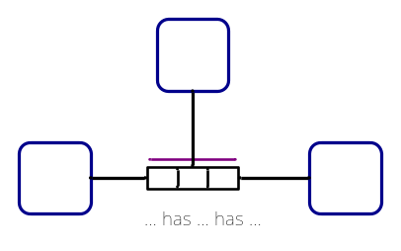
    - For each 3-n role fact type and many-to-one objectified fact types, manipulate the CSUC (Child-Sequence Uniqueness Constraints) based on the proxy roles of the last role.
  - Case 4: Fact Type is many-to-many.
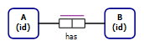
    - Remove the Concept Type for the implicitly objectified Fact Type “A has B”.

- Changing an Internal Uniqueness Constraint
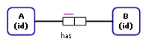
  - Modality:
    - Change from Alethic to Deontic
      - Appropriate remove role
    - Change Deontic to Alethic
      - Appropriate Add rule

  - IsPreferred:
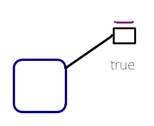
    - Not allowed

    - Not allowed

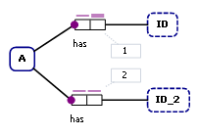
    - Add
      - Get IT for path role, add SCUC with isPref = “true”

    - Delete
      - Get IT for path role, change SCUC to isPref = “false”

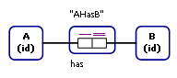
    - Add role EntityTypeHasPreferredIdentifier
    - Give Entity Type preferred ID.
*note: Currently the tool does not allow one to a one objectified relationship in which one role is not the preferred identifier.

- Changing an Internal Uniqueness Constraint
  - Role Sequence Changed
    - Case 1: Fact type is binary and has one single-role uniqueness constraint on it. The existing uniqueness constraint is changed to span both roles.
      - Process this change in the same way that Internal Uniqueness Constraint > Add > Case 4 was handled, but also remove the Information Type or Concept Type Ref that existed for the relationship previous to the change.
- Case 2: Fact type is binary and has one spanning uniqueness constraint on it. The existing uniqueness constraint is changed to span only one role.
      - Process this change in the same way that Internal Uniqueness Constraint > Add > Case 2 was handled, but also remove the Concept Type for the implicitly objectified Fact Type “A has B”.
    - Case 3: Fact type has 3 – n roles or is an objectified fact type either with a non-spanning uniqueness constraint or no uniqueness constraint. The uniqueness constraint on the fact type is changed to span more roles.
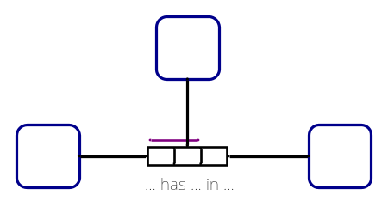
      - Changing the uniqueness constraint here maps to changing the Concept Type Child objects associated with a Child Sequence Uniqueness Constraint. For each role that was added or removed, go to that role’s proxy and find the Concept Type Child object that were absorbed along that Path Role for the compositely-identified fact type.

